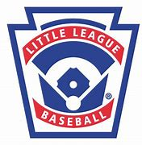 | Portville Little League  49 N. Main Street  PO Box 378  Portville, NY 14770

March 20th, 2023

Dear Sponsor,

We are writing to you to let you know of the Portville Little League baseball season sponsorship opportunities for businesses. This is a great way to help support Portville Little League and advertise your business at the same time.

There are two different opportunities for businesses as follows:

- Team Uniform Sponsorship – This provides a Little League team with team shirts displaying your company name.

- Business Advertisement Banner Sponsorship – This provides a space to advertise your business on a banner to be hung in the outfield of the Major League field for the season.

Please see the attached form for all sponsorship opportunities available and check all that apply. Send the completed form and your remittance to the address listed at the top of the form ASAP as this year’s season begins May 6th.

If you have any questions, please do not hesitate to contact me at (716) 474-6540 via text message/phone call or by emailing me at gsuain@yahoo.com.

We appreciate your support and look forward to creating a partnership with you.

Sincerely,
Gina Suain
Gina Suain
Portville Little League Secretary

